States of Matter

Cut out and complete the following table:
PROPERTIES OF THE STATES OF MATTER
SOLID | LIQUID | GAS

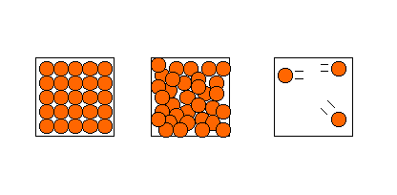

- Have a constant shape
- Take the shape of the container
- Take the shape of the
container and fill it completely
- Can be poured
- Cannot be poured
- Can be poured
- Cannot be compressed
- Can be compressed
- Cannot be compressed
- Top surface always level
- Top surface not level
- Top surface not level
- Expand a little when heated
- Expand more when heated
- Expand much more when
heated

